1. **Agenda**:
   1. How are reports generated in Cucumber?
2. Till now we observed counts for passed and failed scenarios but from business perspective, how to generate reports such as HTML, JSON, XML etc.
3. We want the passed tests in green and failed ones in red for clarity.
4. Graphical user interface, text, application

   Description automatically generated  
     
   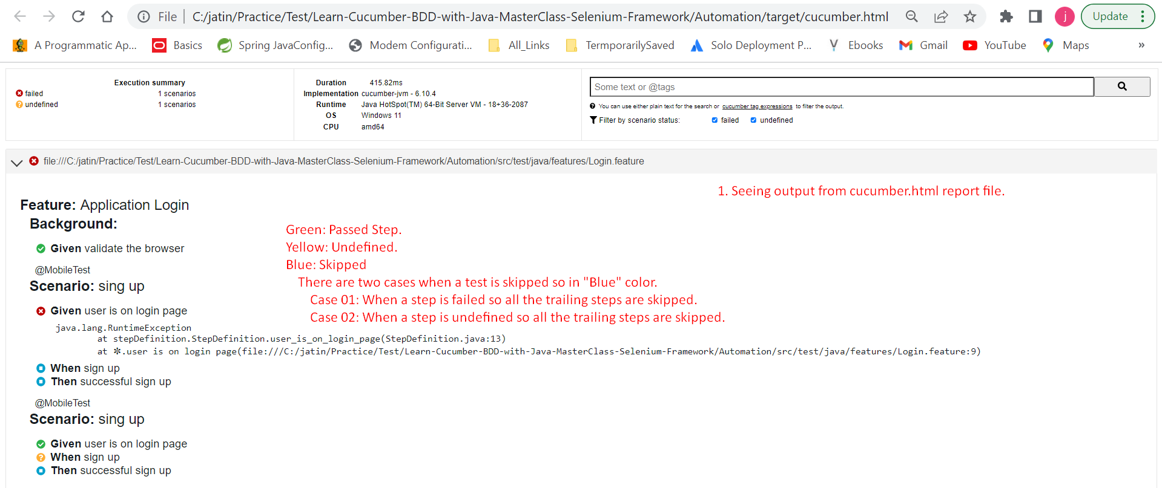  
   JSON, XML formats can be used as input files when creating some chart diagrams like Pie Chart, Bar Charts.  
     
   Let’s talk about **“pretty”** in option.  
   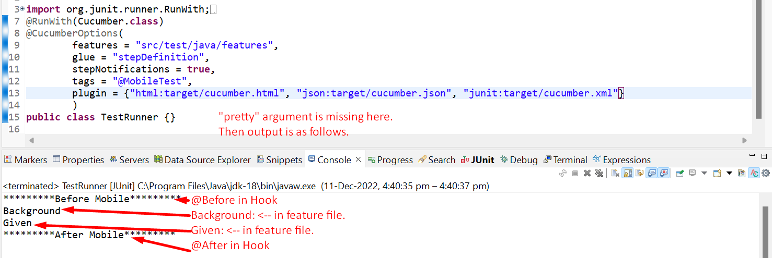  
     
   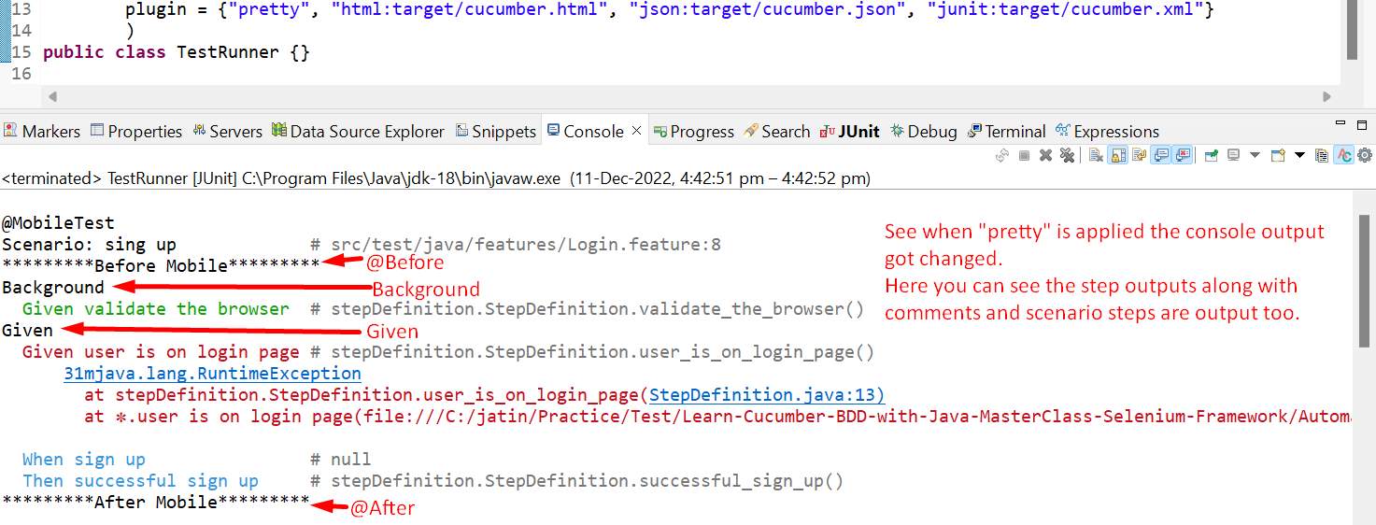
5. This is the file which BA gives you and the same file you report back after automating the test cases / scenarios.